Test Case: tc008_SPX_Dev5_Validacion_Boton_Remove_Administrador_Menu
Step 1 - Enter username and password and click to button Enter : Credentials Entered
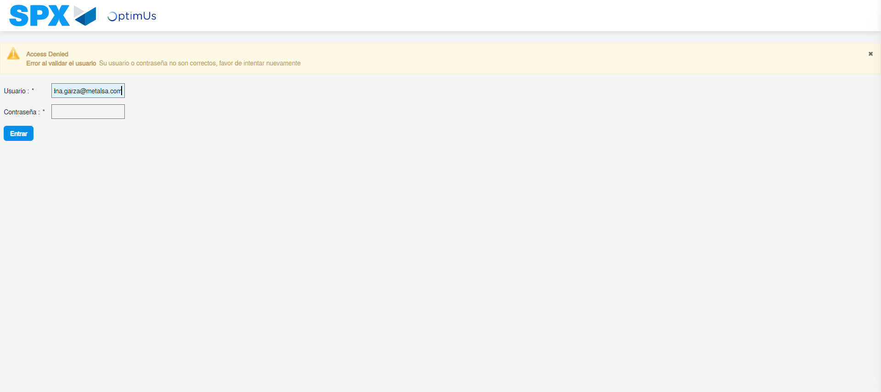Image file-name: QC_Testing-tc008_SPX_Dev5_Validacion_Boton_Remove_Administrador_Menu-may. 15 2024, 01 04 24 p. m.

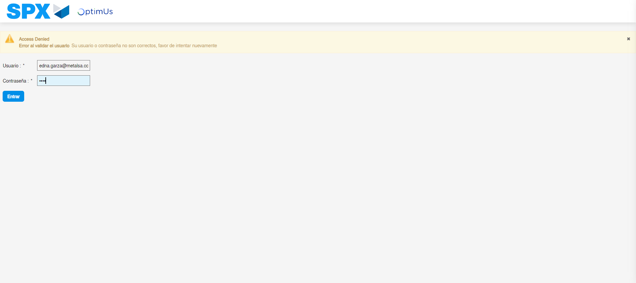Image file-name: QC_Testing-tc008_SPX_Dev5_Validacion_Boton_Remove_Administrador_Menu-may. 15 2024, 01 04 25 p. m.

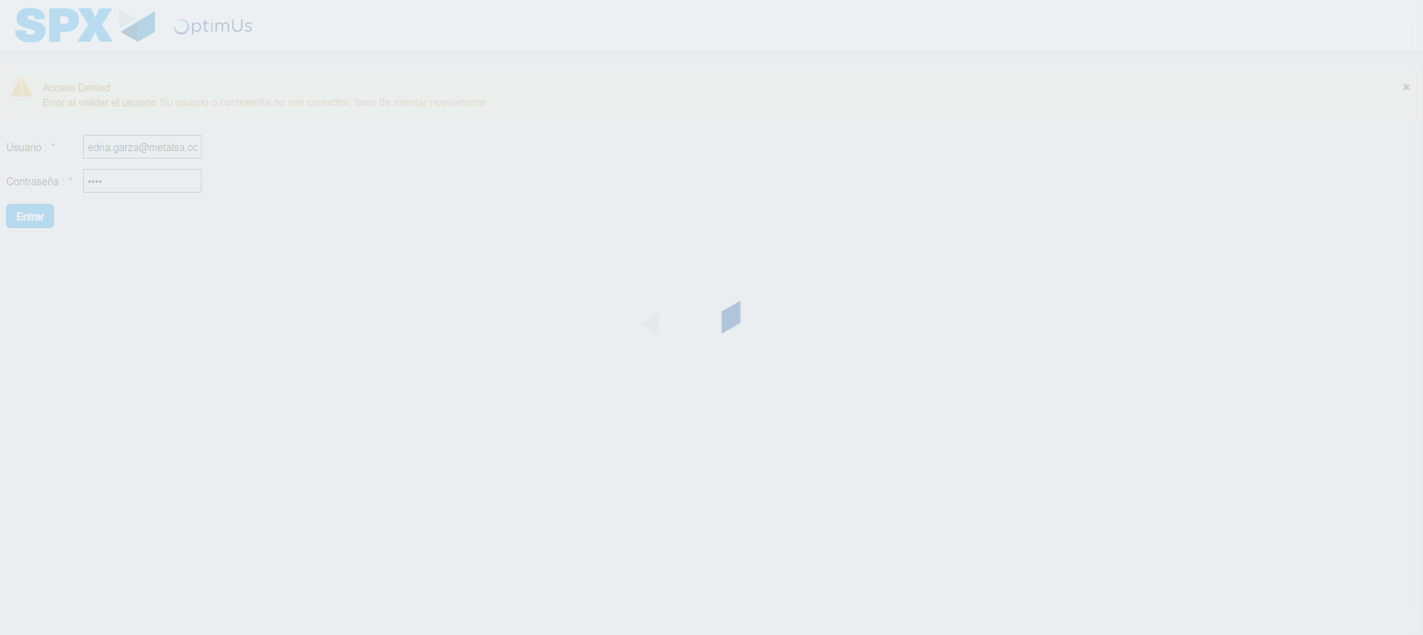Image file-name: QC_Testing-tc008_SPX_Dev5_Validacion_Boton_Remove_Administrador_Menu-may. 15 2024, 01 04 26 p. m.

Step 2 - Select to UEN and Access to Administrador Roles Menu: UEN Correctly selected and Correct access
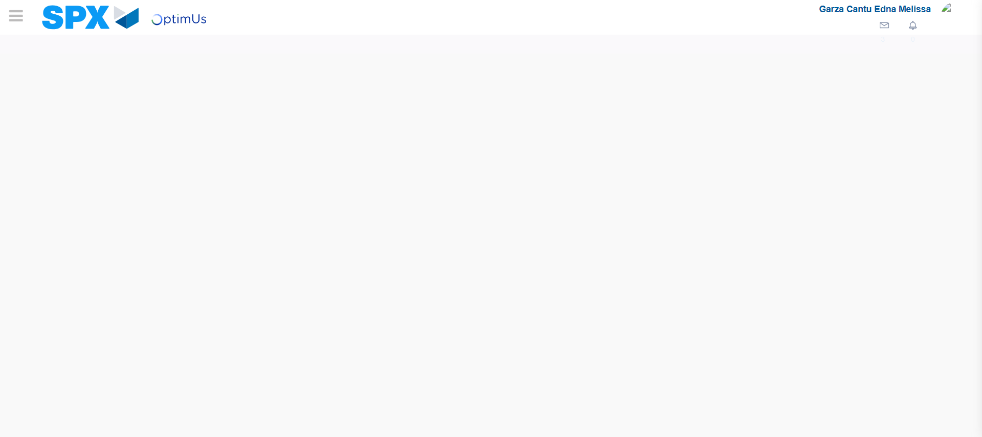Image file-name: QC_Testing-tc008_SPX_Dev5_Validacion_Boton_Remove_Administrador_Menu-may. 15 2024, 01 04 30 p. m.

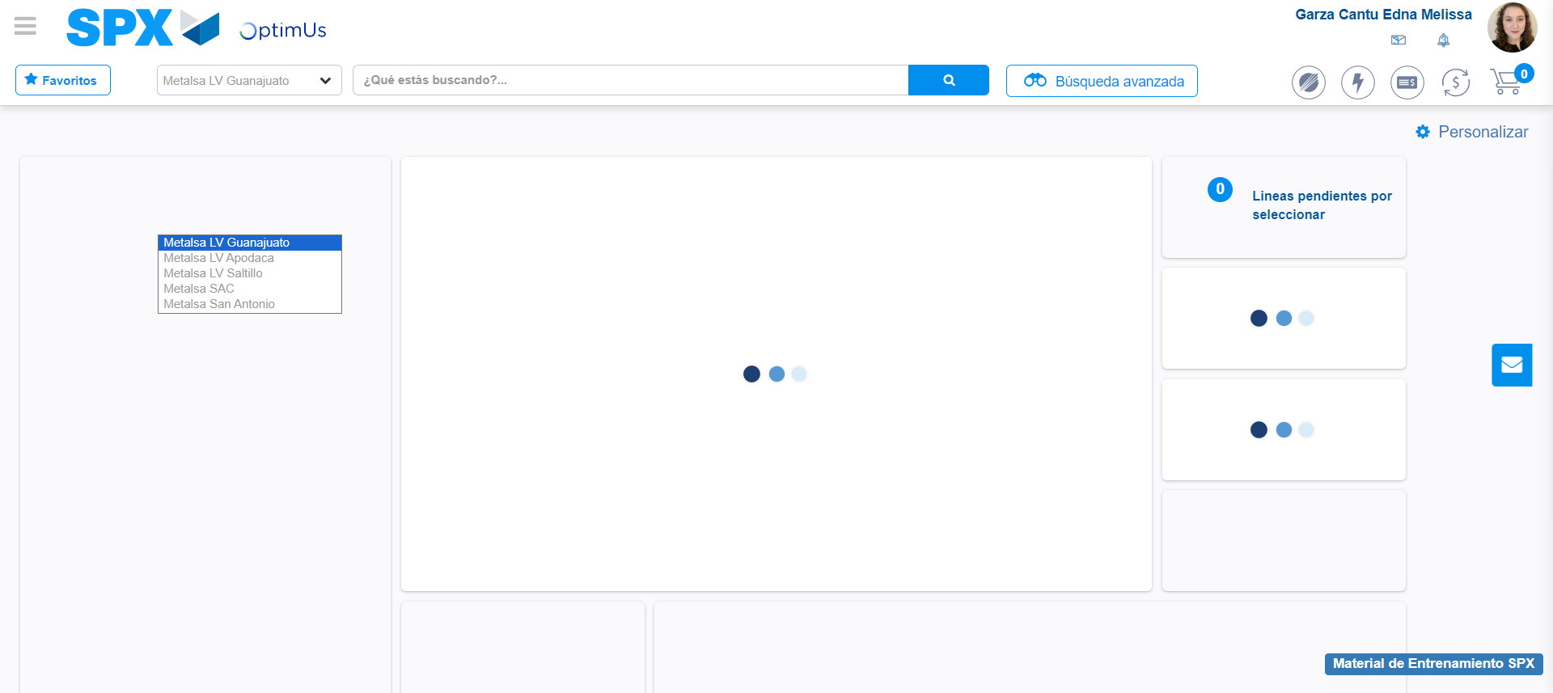Image file-name: QC_Testing-tc008_SPX_Dev5_Validacion_Boton_Remove_Administrador_Menu-may. 15 2024, 01 04 31 p. m.

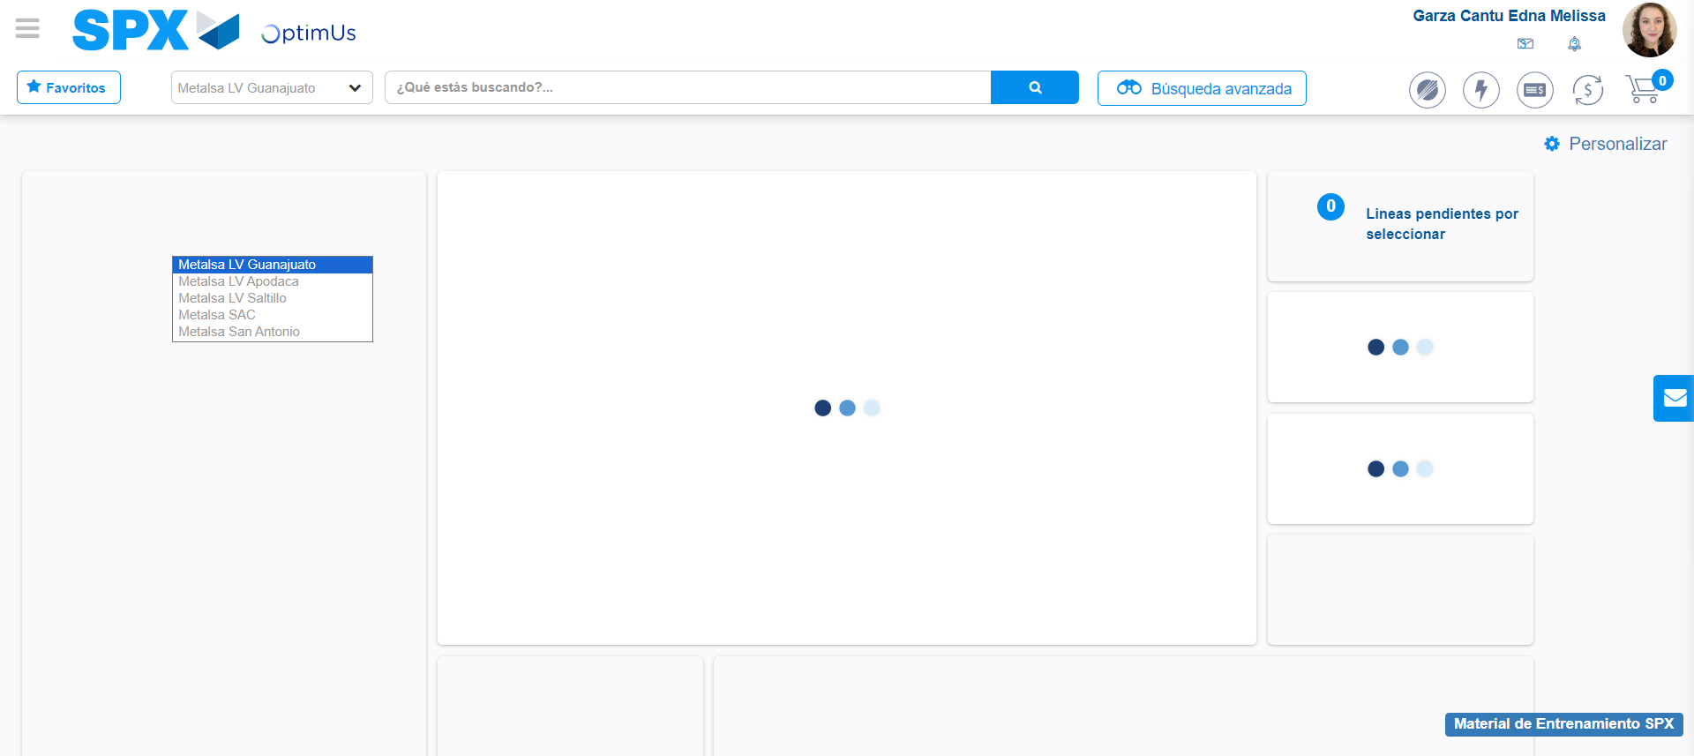Image file-name: QC_Testing-tc008_SPX_Dev5_Validacion_Boton_Remove_Administrador_Menu-may. 15 2024, 01 04 32 p. m.

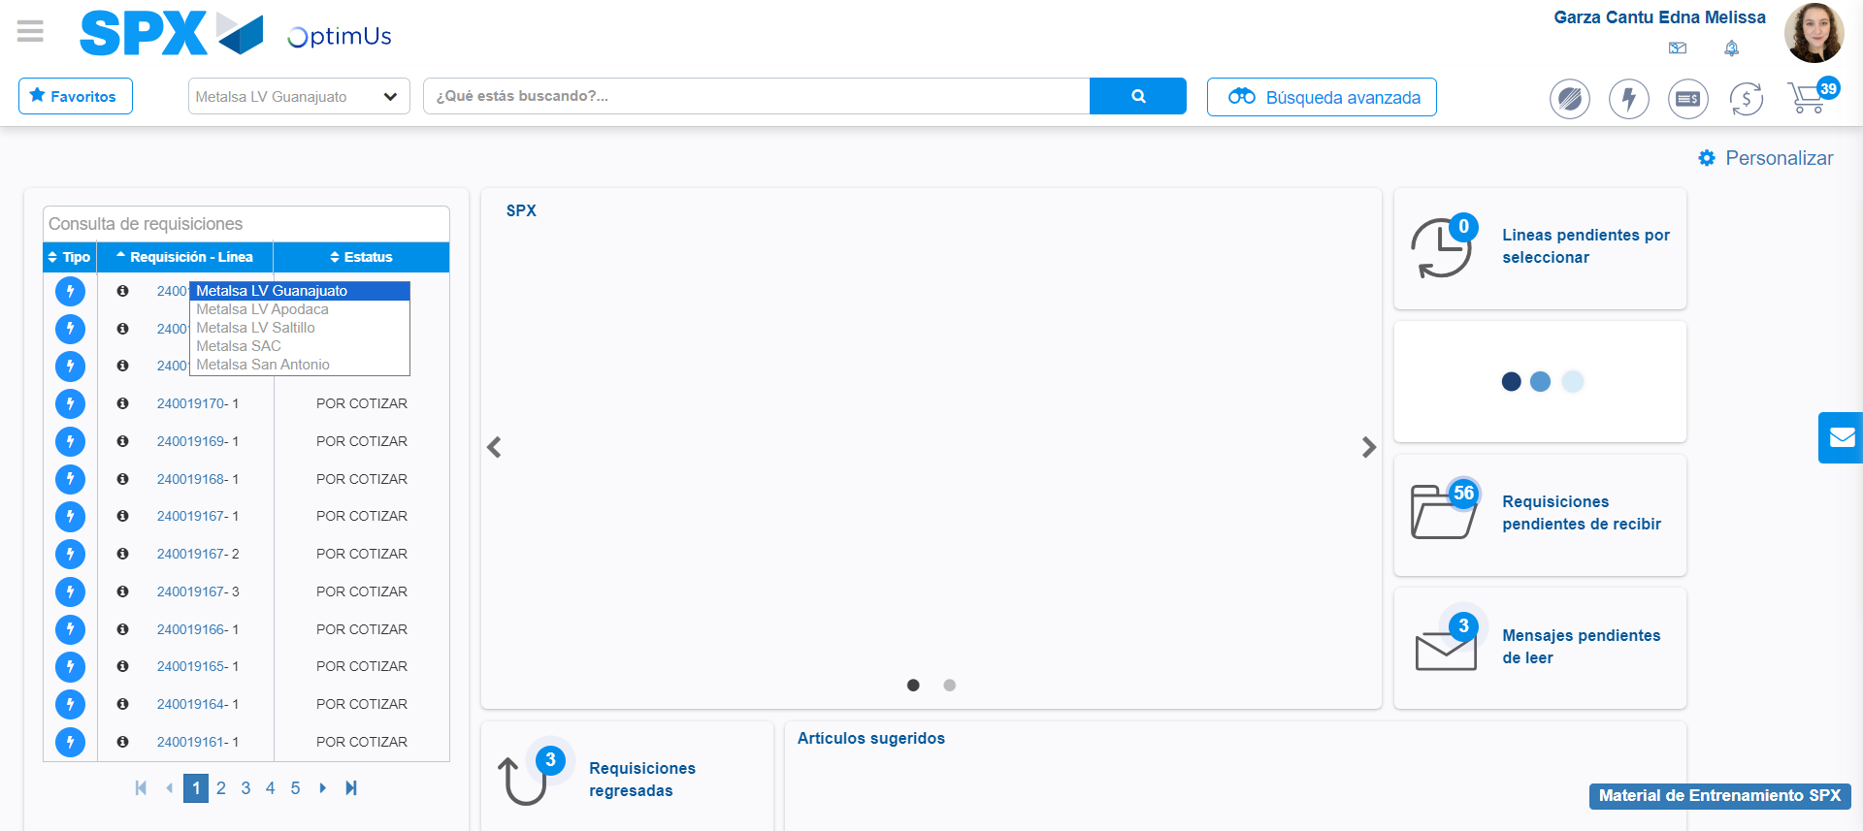Image file-name: QC_Testing-tc008_SPX_Dev5_Validacion_Boton_Remove_Administrador_Menu-may. 15 2024, 01 04 33 p. m.

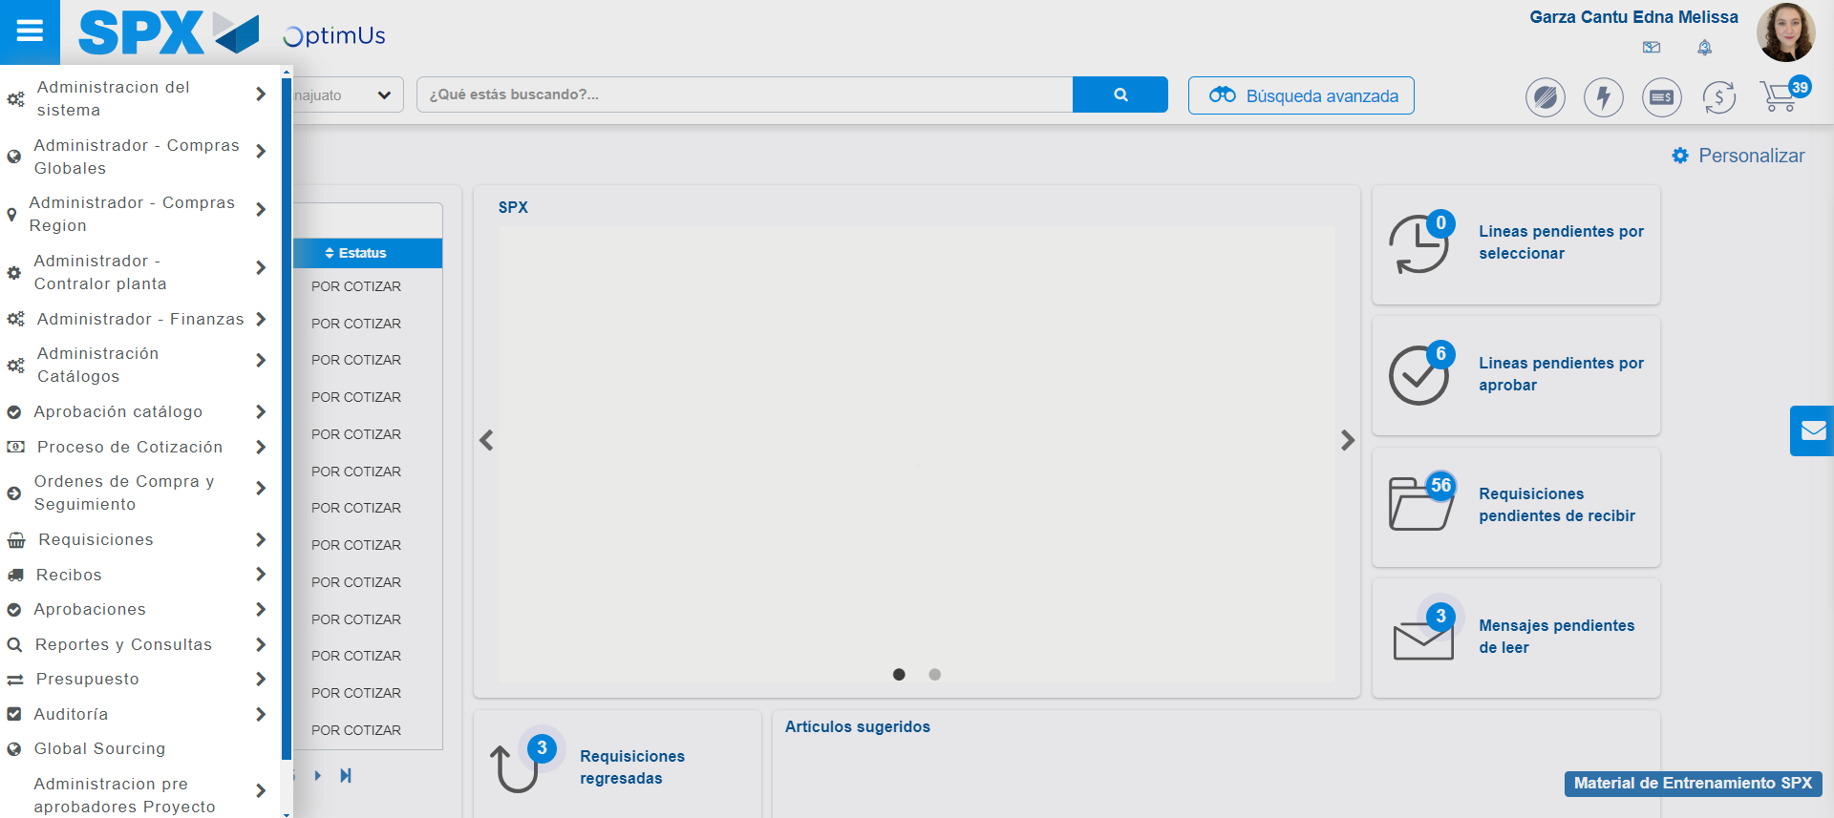Image file-name: QC_Testing-tc008_SPX_Dev5_Validacion_Boton_Remove_Administrador_Menu-may. 15 2024, 01 04 34 p. m.

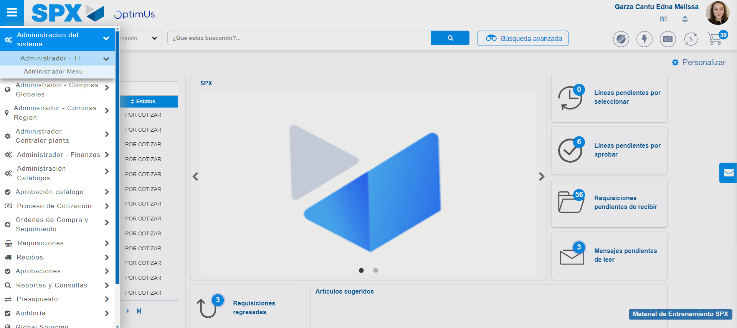Image file-name: QC_Testing-tc008_SPX_Dev5_Validacion_Boton_Remove_Administrador_Menu-may. 15 2024, 01 04 35 p. m.

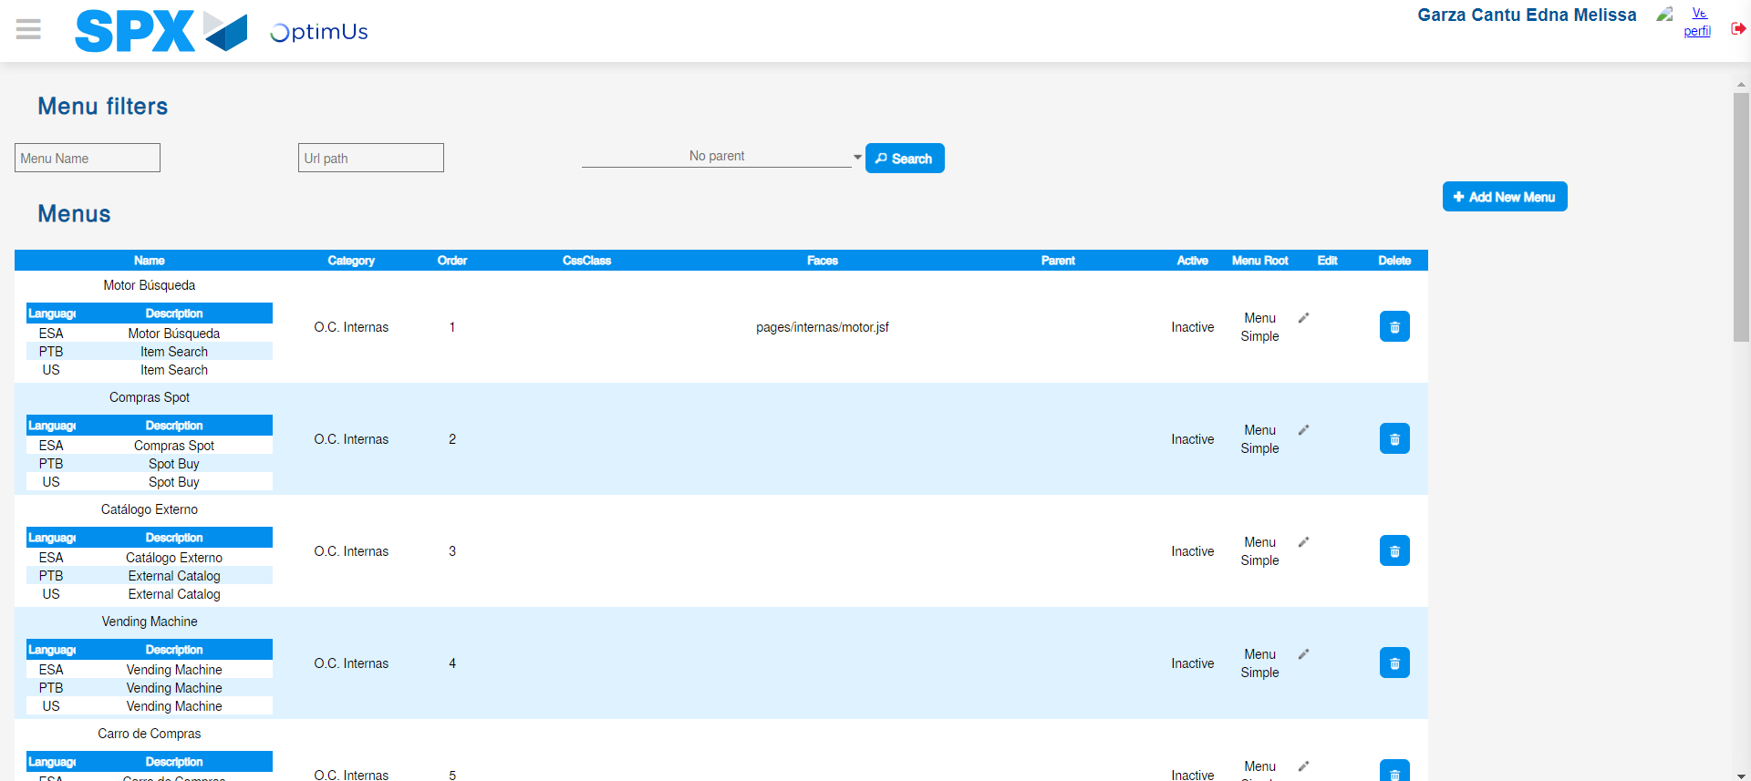Image file-name: QC_Testing-tc008_SPX_Dev5_Validacion_Boton_Remove_Administrador_Menu-may. 15 2024, 01 04 39 p. m.

Image file-name: QC_Testing-tc008_SPX_Dev5_Validacion_Boton_Remove_Administrador_Menu-may. 15 2024, 01 04 40 p. m.

Step 3 - Delete record: Record successfully deleted
Image file-name: QC_Testing-tc008_SPX_Dev5_Validacion_Boton_Remove_Administrador_Menu-may. 15 2024, 01 04 40 p. m.

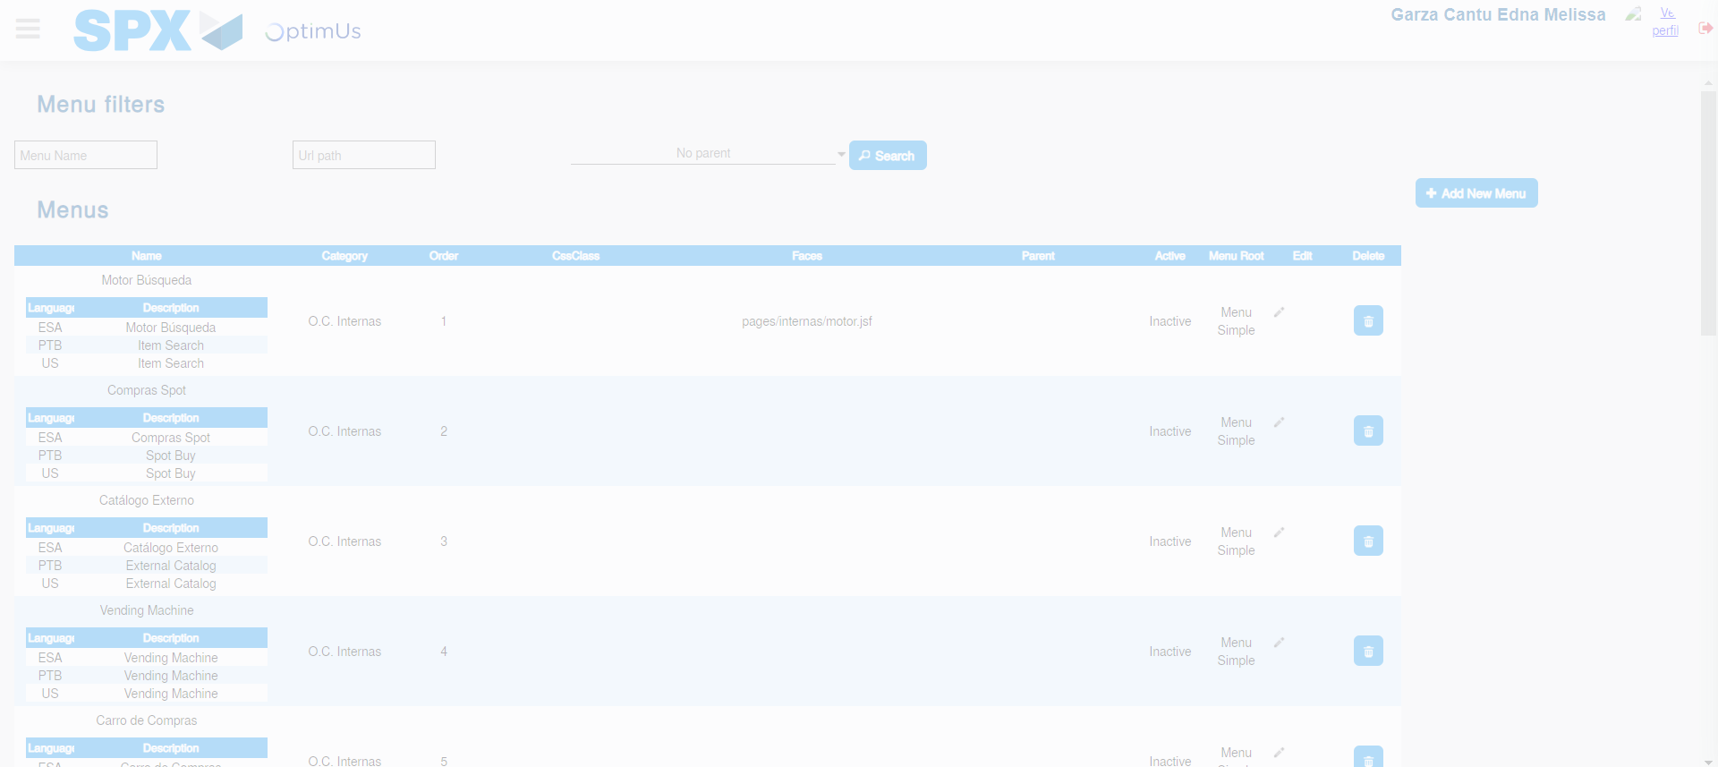Image file-name: QC_Testing-tc008_SPX_Dev5_Validacion_Boton_Remove_Administrador_Menu-may. 15 2024, 01 04 41 p. m.

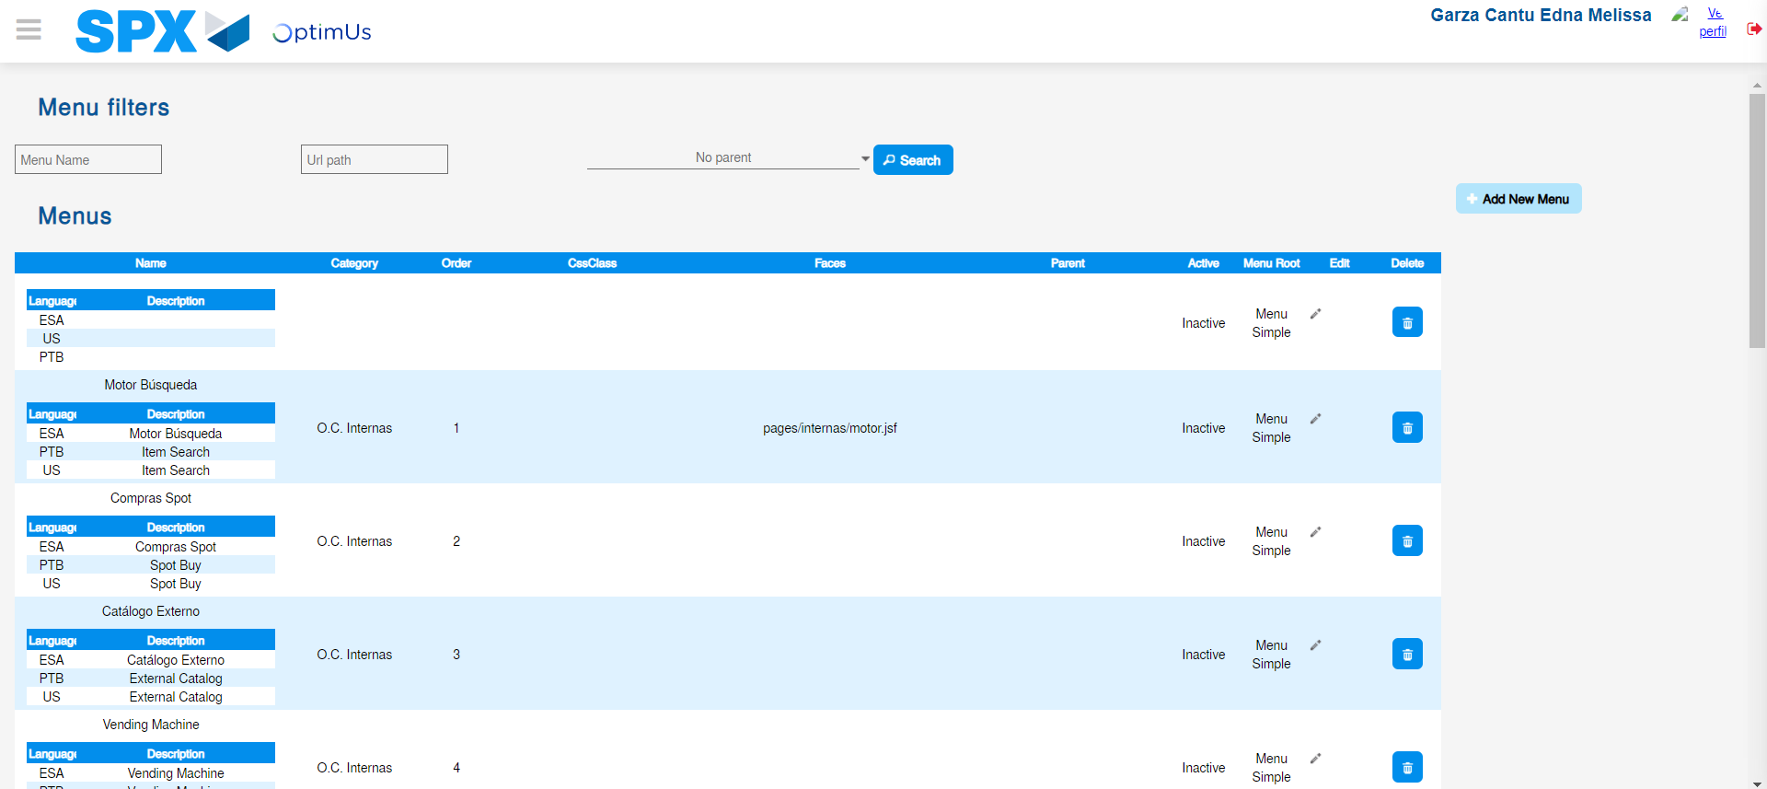Image file-name: QC_Testing-tc008_SPX_Dev5_Validacion_Boton_Remove_Administrador_Menu-may. 15 2024, 01 04 44 p. m.

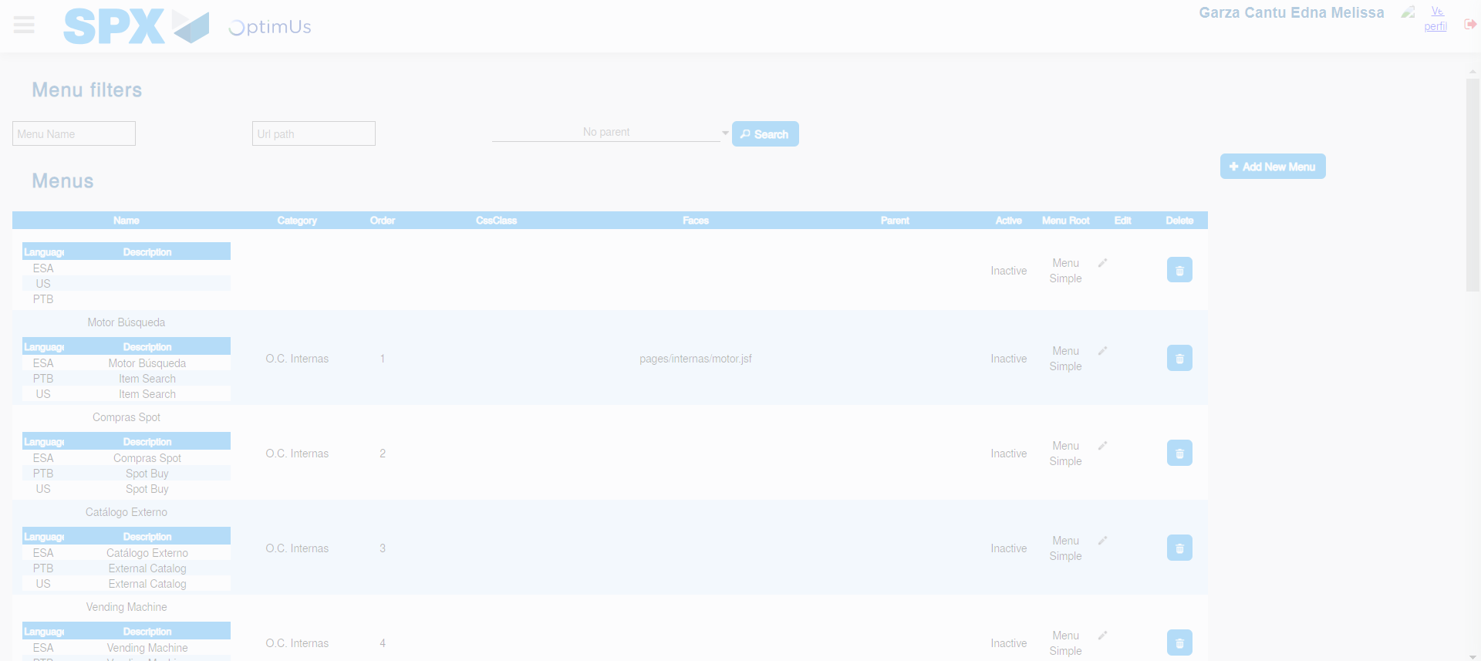Image file-name: QC_Testing-tc008_SPX_Dev5_Validacion_Boton_Remove_Administrador_Menu-may. 15 2024, 01 04 45 p. m.

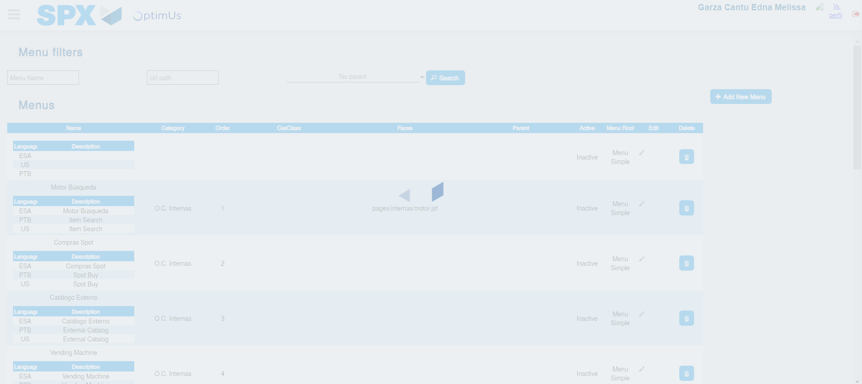Image file-name: QC_Testing-tc008_SPX_Dev5_Validacion_Boton_Remove_Administrador_Menu-may. 15 2024, 01 04 46 p. m.

